Department of Computer Technology

Vision of the Department
To be a well-known centre for pursuing computer education through innovative pedagogy, value-based education and industry collaboration.

Mission of the Department
To establish learning ambience for ushering in computer engineering professionals in core and multidisciplinary area by developing Problem- solving skills through emerging technologies.

Session 2025-2026
Mission: Means to achieve Vision
Vision: Dream of where you want.

Program Educational Objectives of the program (PEO): (broad statements that describe the professional and career accomplishments)
PEO1 | Preparation | P: Preparation | Pep-CL abbreviation  pronounce as Pep-si-lL easy to recall
PEO2 | Core Competence | E: Environment (Learning Environment)
PEO3 | Breadth | P: Professionalism
PEO4 | Professionalism | C: Core Competence
PEO5 | Learning Environment | L: Breadth (Learning in diverse areas)

Program Outcomes (PO): (statements that describe what a student should be able to do and know by the end of a program)

Keywords of POs:
Engineering knowledge, Problem analysis, Design/development of solutions, Conduct Investigations of Complex Problems, Engineering Tool Usage, The Engineer and The World, Ethics, Individual and Collaborative Team work, Communication, Project Management and Finance, Life-Long Learning
PSO Keywords: Cutting edge technologies, Research
“I am an engineer, and I know how to apply engineering knowledge to investigate, analyse and design solutions to complex problems using tools for entire world following all ethics in a collaborative way with proper management skills throughout my life.” to contribute to the development of cutting-edge technologies and Research.

Integrity: I will adhere to the Laboratory Code of Conduct and ethics in its entirety.

Name and Signature of Student and Date
(Signature and Date in Handwritten)

Department of Computer Technology

Vision of the Department
To be a well-known centre for pursuing computer education through innovative pedagogy, value-based education and industry collaboration.

Mission of the Department
To establish learning ambience for ushering in computer engineering professionals in core and multidisciplinary area by developing Problem- solving skills through emerging technologies.

Session | 2025-26 (ODD) | Course Name | Operating System Lab
Semester | 5 | Course Code | 23IOT1504
Roll No | 01 | Name of Student | Anushka Yede

Practical Number | Practical no 8
Course Outcome | - Understand Computer System Configuration and Simulate system resources efficiently using Linux Commands (CO1)  - Analyse operating system functionalities utilizing system calls, thread programming and process scheduling algorithms (CO2)  - Apply Synchronization primitives to implement a Deadlock-free solution(CO3)  - Simulate Disk scheduling, Memory allocation, File allocation, page replacement algorithms (CO4)
Aim | Develop a program to provide synchronizes among the 5 philosophers in dinning philosopher problem using semaphore
Problem Definition | The aim of this program is to simulate the Dining Philosophers Problem, where five philosophers sit around a table with a plate of food and five chopsticks. Each philosopher alternates between thinking and eating.  To eat, a philosopher needs two chopsticks — one on the left and one on the right.  The challenge is to design a solution using semaphores so that no two philosophers use the same chopstick at the same time, avoiding deadlock and ensuring synchronization.
Theory  (100 words) | The Dining Philosophers Problem is a classic example of synchronization in operating systems. It illustrates how processes (philosophers) compete for limited shared resources (chopsticks).  Each philosopher needs two chopsticks to eat but can only pick one at a time.  If all philosophers pick up one chopstick simultaneously, they may wait forever — this is a deadlock.  Using semaphores, we control access to chopsticks. Each semaphore represents a chopstick.  A philosopher must wait (decrement) before picking and  signal (increment) after releasing.  This ensures mutual exclusion and smooth resource sharing.

Procedure and Execution  (100 Words) | Start the program.  Initialize five semaphores, one for each chopstick, all set to 1 (available).  Create five philosopher threads, each representing a philosopher’s life cycle.  Each philosopher alternates between thinking and eating.  Before eating, the philosopher waits for both left and right chopsticks (using semaphore wait).  After eating, the philosopher releases both chopsticks (using semaphore signal).  Display which philosopher is eating or thinking. Continue for some time, then stop the simulation.
Code
#include <stdio.h> #include <pthread.h> #include <semaphore.h> #include <unistd.h>
#define N 5 // Number of philosophers sem_t chopstick[N];
pthread_t philosopher[N];
int phil_num[N] = {0, 1, 2, 3, 4};
void *philosopher_func(void *num) { int id = *(int *)num;
while (1) {
printf("Philosopher %d is thinking 🍵\n", id + 1); sleep(1);
// Pick up left and right chopsticks sem_wait(&chopstick[id]); sem_wait(&chopstick[(id + 1) % N]);
printf("Philosopher %d is eating \n", id + 1); sleep(2);
// Put down chopsticks sem_post(&chopstick[id]); sem_post(&chopstick[(id + 1) % N]);
printf("Philosopher %d finished eating and is thinking again
\n", id + 1);
sleep(1);
}
}
int main() { int i;
for (i = 0; i < N; i++) sem_init(&chopstick[i], 0, 1);

for (i = 0; i < N; i++)
pthread_create(&philosopher[i], NULL, philosopher_func, &phil_num[i]);
for (i = 0; i < N; i++) pthread_join(philosopher[i], NULL);
for (i = 0; i < N; i++) sem_destroy(&chopstick[i]);
return 0;
}
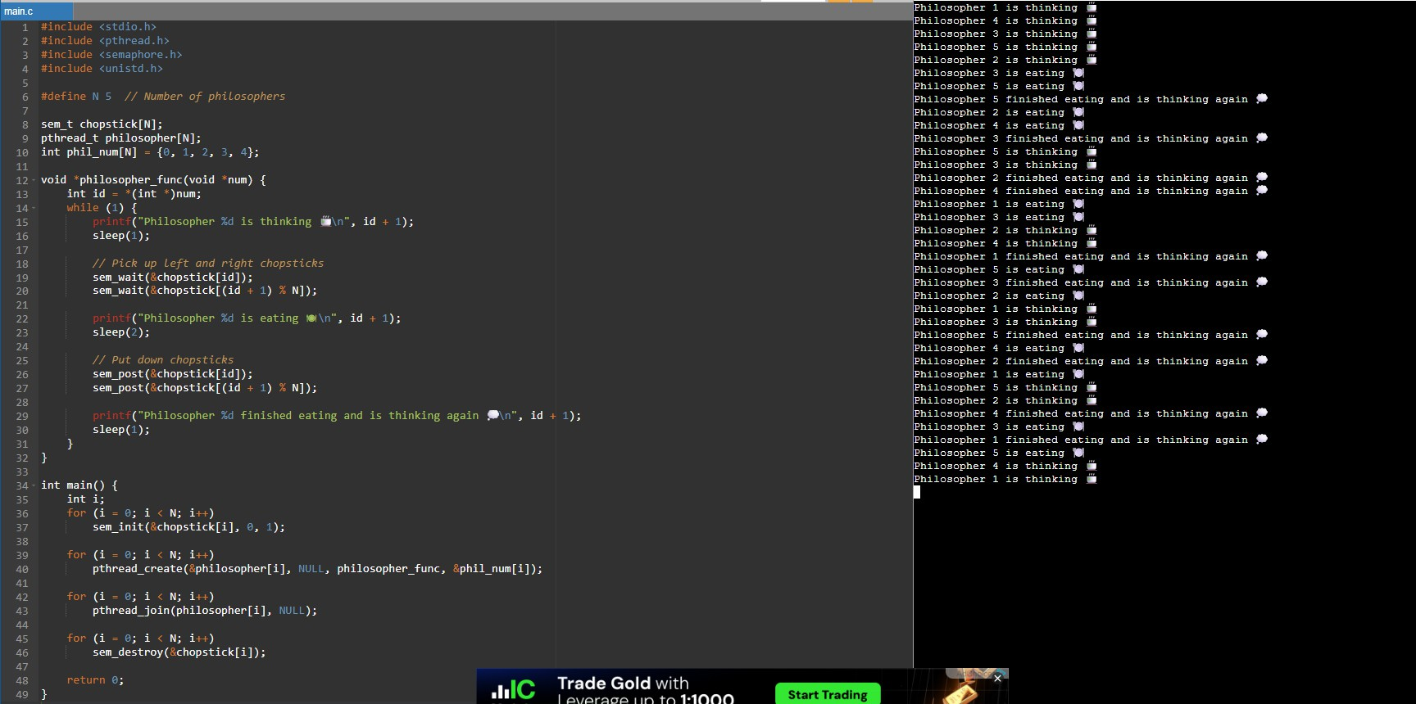
Output:

Department of Computer Technology

Vision of the Department
To be a well-known centre for pursuing computer education through innovative pedagogy, value-based education and industry collaboration.

Mission of the Department
To establish learning ambience for ushering in computer engineering professionals in core and multidisciplinary area by developing Problem- solving skills through emerging technologies.

Output Analysis | The output shows that philosophers take turns eating and thinking.  At any time, no two neighboring philosophers eat simultaneously, proving that chopsticks (shared resources) are used safely.  There’s no deadlock or starvation, as every philosopher eventually gets a chance to eat. The semaphore mechanism maintains proper synchronization among all philosophers.
Link of student Github profile where lab assignment has been uploaded
Conclusion | The program successfully demonstrates process synchronization using semaphores.  It ensures that philosophers (processes) access shared resources (chopsticks) safely without deadlock.  This approach maintains balance between resource utilization and process coordination, showing how semaphores effectively solve real-world synchronization problems in operating systems.
Plag Report (Similarity index < 12%) | 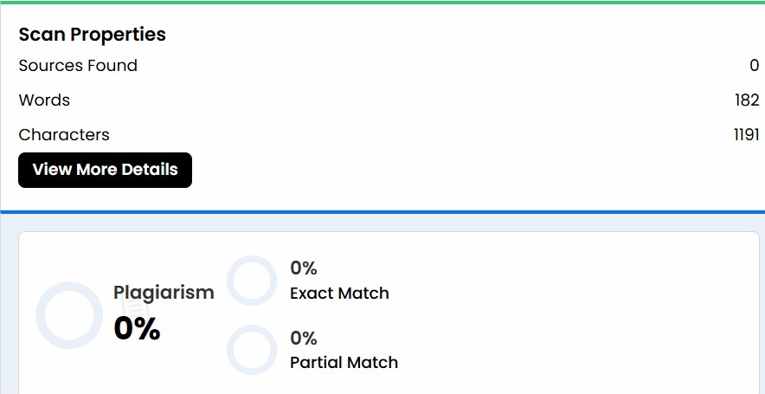
Date | 29/10/25

